Weekly Construction Progress Report – Week 24
Harrow Bay Offshore Wind · 08 Jun – 14 Jun 2026
Elena Márquez · 15 June 2026 · HB-PM-RPT-2026-W24

1. Summary
1 monopile (HB-A09) was installed this week, bringing the total to 9 of 40. The foundation campaign is 1 pile behind the Rev 2 baseline (10 planned). Waiting on weather amounted to 22 hours.
Area | Status | Comment
Overall schedule | Amber | 9/40 monopiles vs. 10 planned
Foundations | Amber | TPs installed: 8
Offshore substation | Green | Fabrication / load-out
Cables | Green | Manufacturing on schedule
HSE | Green | No incidents

2. Progress
Metric | This week | Cumulative | Plan (cum.) | Variance
Monopiles installed | 1 | 9 | 10 | -1
Transition pieces installed | 0 | 8 | – | –
Waiting on weather (h) | 22 | 183 | – | –
Persons on board (avg.) | 95 | – | – | –
Man-hours MV Sea Atlas | 8,182 | 82,098 | – | –
Lost time injuries | 0 | 0 | 0 | 0
Recordable injuries | 0 | 0 | – | –
Near misses reported | 0 | 3 | – | –
HSE observation cards | 18 | – | – | –

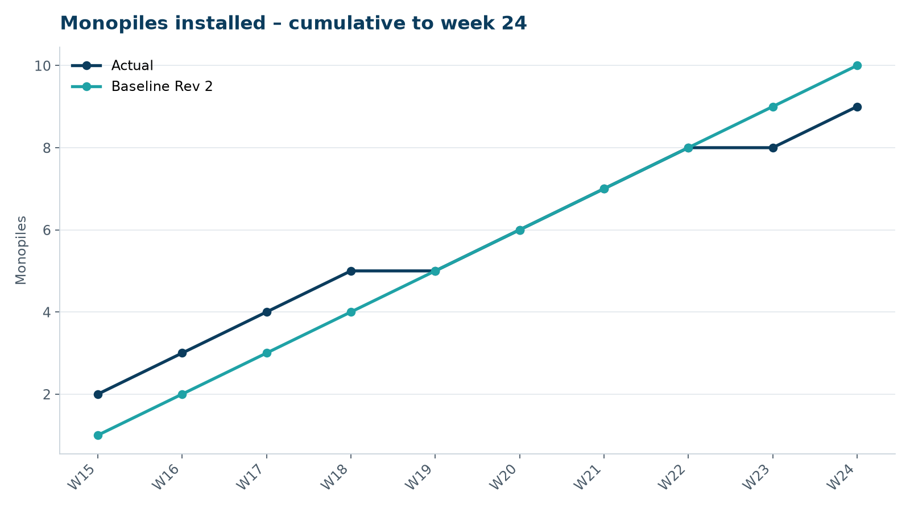
Figure 1 – Monopile installation progress, W15 to W24

3. Key activities this week
- HB-A09 installed on 14 June.
- Investigation of HSE-INC-2026-018 completed (root cause: missing split pin on a bow shackle; pre-use inspection did not check secondary retention).
- OSS jacket loaded out at the fabrication yard.

4. Health and safety
No lost time injuries. 18 observation cards submitted; top theme: mooring line handling.

5. Environment
- HB-A09: peak 157.4 dB SEL at 750 m (compliant); harbour porpoise detected in the mitigation zone during the pre-piling search, soft start delayed by 20 min.

6. Issues and risks
- HB-RISK-001 weather: 22 h downtime this week.
- HB-RISK-009 dropped objects – score reviewed after HSE-INC-2026-018.

7. Look-ahead next week
Load-out for HB-A10 to HB-A12; OSS jacket sail-away.
Prepared by Project Controls (Gareth Lewis); approved by Elena Márquez. Distribution: project team, Steering Committee, Halden Turbine Systems, Lenders' Technical Adviser.

